PACMAN OOP project report
Student: Roghaye Saadabadi
Student id: 404463707
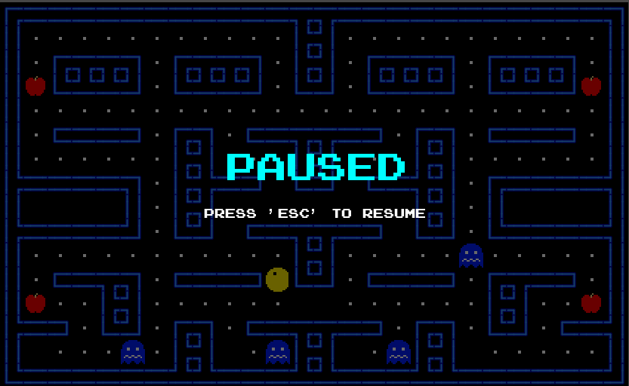
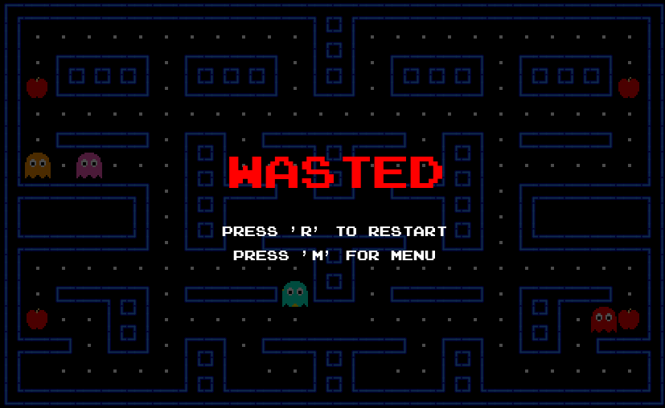
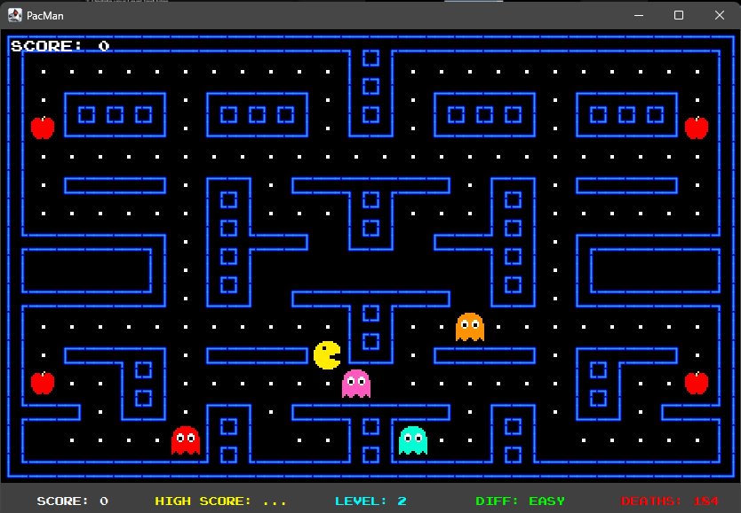
Overview

Project Requirements

Requirement Analysis
- Functional Requirements: "Pac-Man must lose a life when colliding with a red ghost,"
- The game must save the highest score to a text file.
- The user can change the difficulty.
- GUI should be implemented in Swing

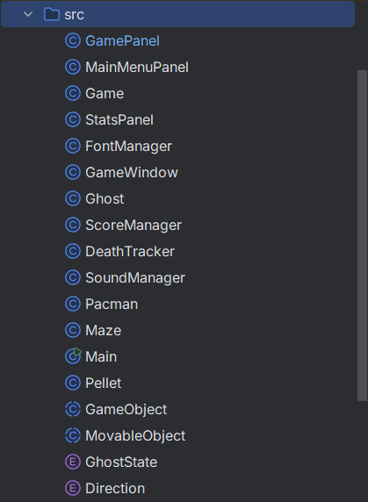
Classes

Game
Pacman
Ghost
Maze
Pellet
ScoreManager

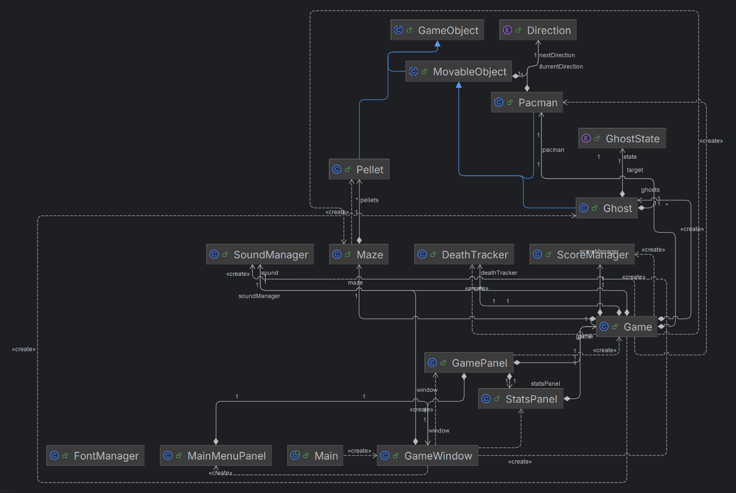

Sequence Diagram
UP arrow key is presswed -> Game detects key press -> Controller updates Pacman direction in the Model -> Model validates the move against the Maze -> Controller tells GamePanel to repaint -> View updates the screen.

Environment

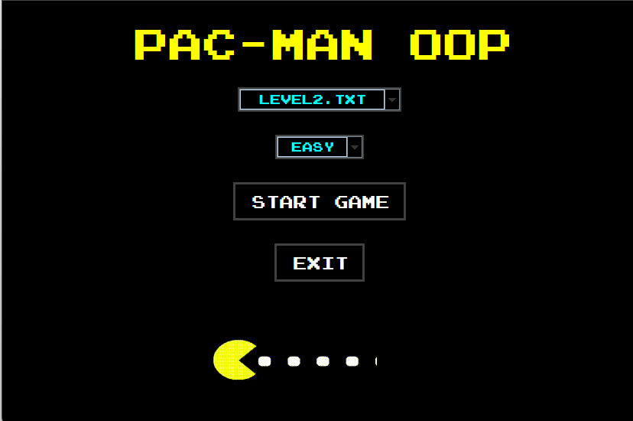
Game Start – Game Exit

We have a main menu for both Starting the Game, Exiting the game, Selecting Game Mode and Selecting Level which will be discussed in later sections
Levels are defined in level folder using Ascii Characters

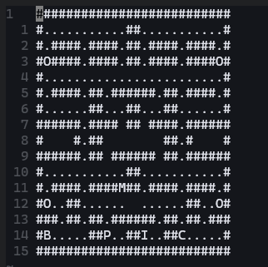
# = wall
M = Pacman Spawn Point
. = Normal Bean
O = Super Pellet (printed as apple fruit)
P = Pinky Ghost
I = Cyan Blue Ghost
C -> Orange Ghost
B -> Red Ghost

Walls, Beans, Pacman, Ghost, HighScore
- Walls, Beans, Pacman, Ghosts are all defined in map Ascii representation
- HighScore is saved in `highscore.txt` file

Maps
as discussed in previous section we can dynamically define maps in levels folder using Ascii Characters

Pacman Style
All assets can be found in Assets folder under main directory of project


Pacman Movement
- you can both control the Pacman using WASD keys or arrow keys
- Pacman can’t bypass the walls
- only moving in allowed directions is allowed

Scoring System
- each key press would lead in one negative score
  - if (maze.isValidMove(nextX, nextY)) {
this.x = nextX;
this.y = nextY;
this.currentDirection = nextDirection;
scoreManager.addScore(-1);
}

- Collecting beans using Pacman would lead in bean deletion
  - for (Pellet p : maze.getPellets()) {
if (p.isActive() && p.getX() == pacman.getX() && p.getY() == pacman.getY()) {
eatenPellet = p;
p.setActive(false);
scoreManager.addScore(10); // Requirement 4c


- Showing Score during the game

- adding 500 scores on collecting all beans
  - if (maze.getPellets().isEmpty()) {
System.out.println("YOU WIN! All beans collected.");
scoreManager.addScore(500); // Requirement 4e
scoreManager.checkAndSaveHighScore();
isGameOver = true;
}

Ghost
- they can move wisely or randomly based on the difficulty level (on Hard Mode they use A* algorithm and they are nearly unbeatable)
- they can’t bypass walls
- they reroute wisely
- they can collide and kill Pacman

Ending
you should either collide with a normal ghost (not frightened) or collect all beans
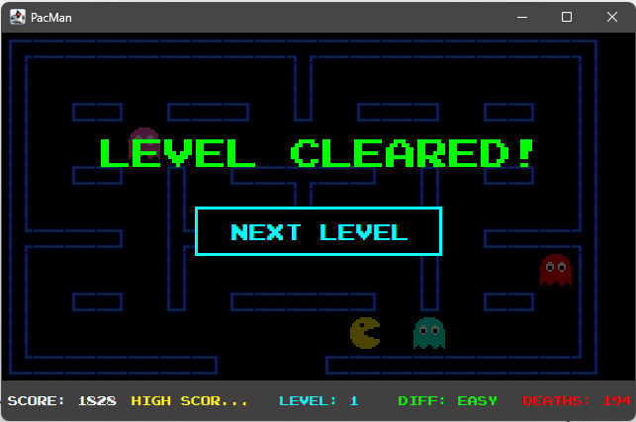

You can also pause the game using escape key

Collision
- Pacman and ghosts can’t bypass walls or the border defined in the map
- you would stop moving on collision with walls
- ghosts choose new direction on collision with walls
- beans get deleted on collision with Pacman
- beans would lead in score increasing during the game

Saving Score
we store highest score of the player in highscore.txt file in main project folder

Documentation

How to run the project
you can the project by easily cloning the repository and running mian.java.

Classes
they are fully described in comments of the source codes

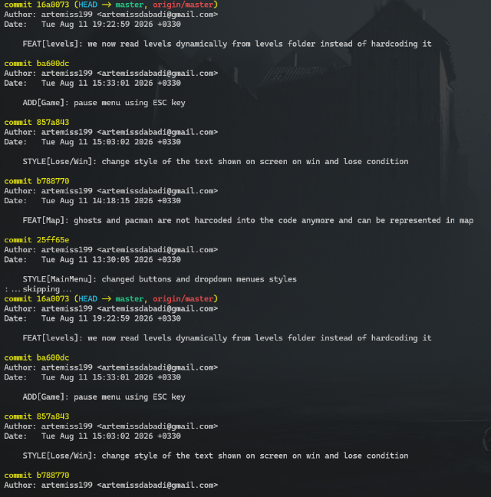
Git
I have used git repeatedly during the project you can see meaningful commits during development
https://github.com/artemiss199/Pacman

Additional

Power Pellet
power pellets are represented as apples in the game you can eat them and make ghosts frightened
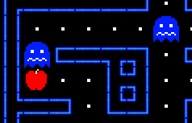
private void checkGhostCollisions() {
// Pacman hits Ghost (Requirement 6a)
for (Ghost g : ghosts) {
if (g.getX() == pacman.getX() && g.getY() == pacman.getY()) {
if (g.getState() == GhostState.FRIGHTENED) {
soundManager.playSound("eatghost");
scoreManager.addScore(200);
g.respawn();
} else {
you can receive 200 scores by eating a frightened ghost
ghosts would jump back to their spawn point immediately after being eaten

Multi Level
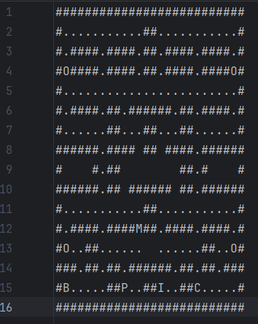
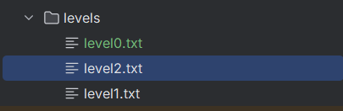
you can define you own custom map in levels folder as I did

# = wall
M = Pacman Spawn Point
. = Normal Bean
O = Super Pellet (printed as apple fruit)
P = Pinky Ghost
I = Cyan Blue Ghost
C -> Orange Ghost
B -> Red Ghost (Blinky)
So, you can have as many ghosts as you want

Music
all sound effects can be found in Assets/sfx folder
we have sfx for:
- Main menu
- Game start
- Pacman eating beans
- Pacman eating ghost
- Losing

Advanced Tracking Algorithms
we use A* with a bit of inaccuracy and mis-prediction (dumb acting) based on the difficulty level
if you want to use 100% accuracy, just put the difficulty on Hard in the main menu.
you can find fully explained implementation in Ghost.java file with explanation on the code
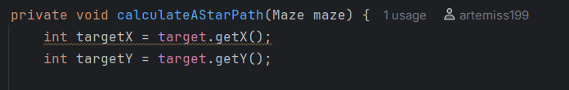

AI Usage
I’ve mainly used IDE’s code completion rather than giving prompt to ai for whole implementation.
Ai helped me on choosing tools for GUI (specially how to render walls better than default dark blue blocks based on their neighbors)
rest of the code like A* implementation or etc. are implemented using help of AI but there is no line of code in the project that was blindly copy pasted and anything that exists in the project is intentional

